Atmospheric Electric Field Measurement with Custom-Built Electric Field Mills
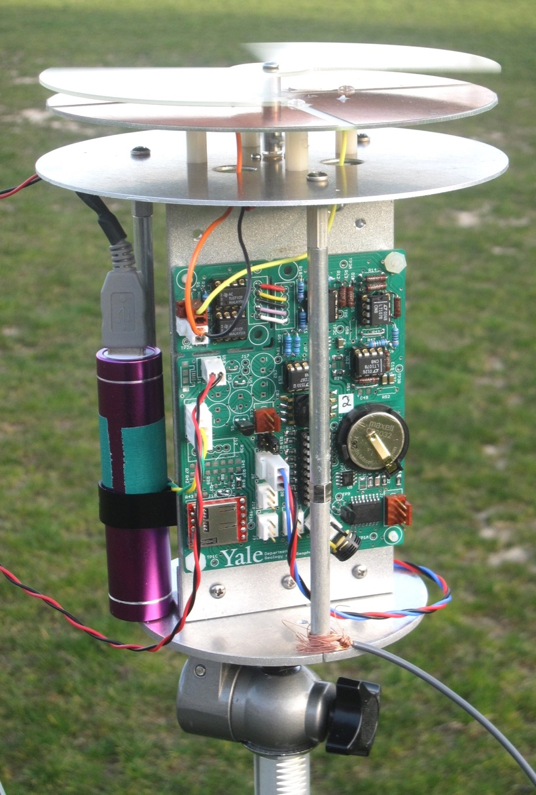

A research project to complete the senior thesis component of the BSc. Degree in
Geology and Geophysics

By Gabriel Roy Liguori

Advised by:
Prof. Ron Smith, Geology & Geophysics Department, Yale University
Paul Fucile, Physical Oceanography Dept., Woods Hole Oceanographic Institution

Funded provided by:
The Von Damm Fellowship
The Mellon Undergraduate Research Grant of Trumbull College
Yale Climate and Energy Institute

Abstract
The objective of this project was to to design, prototype/test, calibrate, and deploy an array of electric field mills capable of sensitive measurements of the electric field. After substantial atmospheric testing, the hope was to test the following two hypotheses. The first being that a wind turbine, by virtue of being a large conductive pole, has a huge interference on the electric field. Then, the second hypothesis is that the spinning blades of the turbine may induce some sort of modulation on the electric field. This is supported by literature on charge dispersal from turbine blades in lightning events, charge accumulation on helicopter blades, and the modulating effects of turbine rotation on other atmospheric scalar qualities, such as humidity and temperature. This project ultimately did not test these hypotheses directly at a turbine site, but rather tested them using proxy experiments that ultimately proved that the sensitivity of the mills would be high enough to later test these hypotheses.
Research Motivation:
I came upon this project during my summer as a Research Assistant at the Woods Hole Oceanographic Institution. Here, I was assisting a PhD student in the Marine Geochemistry Department, and my work centered primarily on calibrating and testing the instrument that was custom-built for his project. Through working on this instrument I was lucky enough to meet Paul Fucile, a Senior Electrical Engineer at WHOI, as he was the designer and programmer for said instrument. Through our many hours working together on the instrument, we stumbled upon this project due to our mutual interest in atmospheric conditions and wind energy. After my experience at WHOI, I had a desire to do a senior research project that relied on my own field experiments and custom instruments. While the project ultimately did not reach some of the later stages of testing with regards to the hypotheses, it was tremendously useful in other aspects. First, more generally, it gave me a much greater understanding of atmospheric electricity, something that I had very little knowledge of going into the project. Then, the process of designing, optimizing and calibrating these field mills was incredibly informative, and is an experience that I hope to rely on later in a career in science. Finally, this part of the project, describing and summarizing the research experience, was very useful as it forced me to fundamentally understand the aspects of the project to describe it to others, and to present my arguments in a convincing fashion.
Background: History of Atmospheric Electricity Research
Below this paper will briefly detail the history of research on the atmospheric electrical field. The foremost work in the field was the well-documented “lightning experiment” of Ben Franklin in 1752. These experiments were instrumental in that they proved the electrical nature of lightning, a previously unproven idea. Then, multiple notable scientists performed rudimentary measurements of fair weather atmospheric conditions, ultimately demonstrating the “electrification” of ambient, non-lightning storm conditions. This included experiments by Lemmonier and Canton who measured the electrical changes in non-lightning conditions. Beccarria in 1775 measured the daily oscillations in atmospheric electricity, noting “the effect of fog on changing the electrical parameters” (Harrison 2004) Finally, de Saussure found evidence of a diurnal variation in his measurements of atmospheric electricity between 1785 and 1788, noting that “the electricity undergoes an ebb and flow like the tides, which increases and decreases twice in the span of twenty-four hours” (Harrison 2004) Although the double peak of the cycle has since been found to be speculative, this experiment “serves to illustrate the readiness with which a diurnal variation could be observed with such early instrumentation” (Harrison 2004) Then, work by Lord Kelvin between 1859-1862 was monumental in shaping the current understanding of the vertical atmospheric electrical potential gradient. His famed “water dropper” experiment demonstrated the existence of an atmospheric potential gradient (PG). Another major contribution of this experiment was that it automatically recorded the field values, making readings much more accurate and precise. (Aplin)
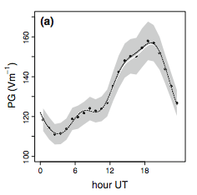
Finally, the hallmark work in the field was conducted by researchers at the Carnegie Institution of Washington on the R/V Carnegie from 1909 until 1929. The group conducted atmospheric measurements at sea during multiple research cruises. The measurements were conducted at sea as it isolated the electrical measurements from traditional “noise” sources that often interfere with the potential gradient on land. Their resulting work was monumental, as it empirically defined the atmospheric potential gradient for both a diurnal and a monthly/seasonal time scale. When taking the average of their data, they found a clearly defined diurnal cycle present in the atmospheric potential gradient. The above picture, reproduced from a summary paper in Survey Geophysics, depicts the diurnal cycle, with a maximum found at 18:00 UT time. (Harrison 2012)

Background: Atmospheric Capacitor Model
The current understanding of the atmospheric electrical circuit was initially depicted by Lord Kelvin in his brief but monumental stint studying atmospheric electricity. This widely-accepted model describes the global electrical circuit as a massive spherical capacitor, with the ionosphere and ground as the two plates. The ionosphere, due to the presence of ionized gases from incoming solar radiation, acts as the positive plate, while the ground acts as the negative plate. In fair weather conditions this results in a weak current from the ionosphere to ground. However, in order for the system to stay in steady state there has to be a mechanism that recharges it. This recharging mechanism comes in the form of thunderstorms anywhere throughout the world. This is because “charge separation inside thunderstorms generates a potential difference, Vi, between the ionosphere and the Earth's surface, causing a small current, known as the air-Earth conduction current, Jz, to flow vertically between the two regions.” (Nicoll)
Groupel plays a significant role in the electrification of these thunderstorms. These aerosols are large enough to experience a dipole moment, and are heavy enough that they either sink or levitate within the updraft of a thunderstorm cloud. Here, they collide with up drafting smaller aerosol particles, during which they lose their positive charge. This causes a positive charge to develop at the bottom of the thunderstorm cloud to counteract the large concentration of negatively charged groupel. At the top of the thunderstorm cloud, the reverse develops, as a negative charge builds up around the top of the cloud to balance its positively charged top. This large disturbance to the normal electric gradient is enough to create a current to counteract the standard ionosphere-to-ground current, thereby balancing the system on the whole. However, this system only stays in balance globally, meaning locally on short time scales the system can be severely out of balance, resulting in reverse polarity fields. (NWS)
Background: Field Mills
Field mills rely on the principle of Gauss’ law, that a material subject to an electric field will experience an induced charge relative to the strength of the orthogonal electric field. However, given the tremendously low conductivity of air near the earths surface, the induced charges on objects are often infinitesimal. To measure these incredibly minute induced charges, field mills rely on the principle of “chopping” in instruments. Relating to field mills, this chopping is performed by the rotating vane above the sensor plates. The rotating vane alternates between exposing and shielding the grounded sensor plate, which results in an alternating current (AC). The induced charge on the sensor plate accumulates in the period that the sensor is exposed, then is sent to ground in the period that it is shielded by the vane. On its way to ground, this induced charge is sent through a series of charge amplifiers. In my field mills, the schematic is as follows
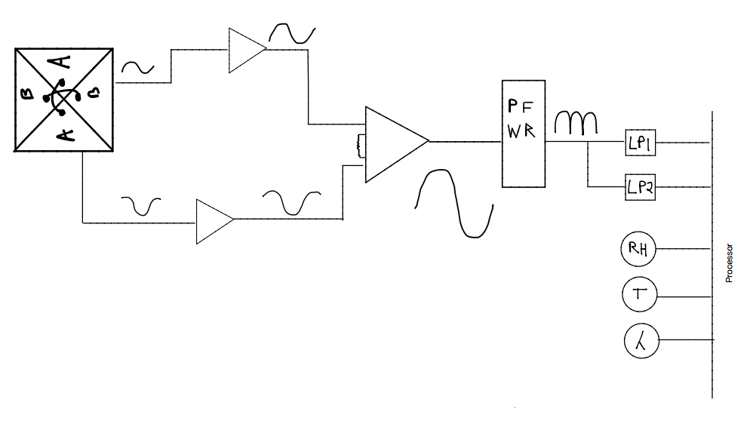
My mill utilizes an orientation that effectively doubles the sensitivity of the mills. Two pairs of sensor plates are placed opposite in a circular arrangement (represented as a square for simplicity). The mills vane only has 2 blades, however, meaning that a pair of sensor plates is always exposed to the atmosphere, effectively doubling the sensitivity and response time of the mill. Each pair of sensors is connected to a current-to-voltage amplifier, although their output is 180° out of phase. A second stage charge amplifier groups these outputs together on one time-series, with the pairs filling in each other’s grounded period temporally. The output from the second stage amplifier is still an AC signal, so it is sent through a precision full-wave rectifier (PFWR) that converts this to a single polarity. The signal is then sent through a filtering stage which averages 40 samples into a single data point. This data is then sent through an analog to digital converter, which outputs to a memory card. Something that will be touched upon later but is crucial to point out now is the influence of the rotating vane on the output signal. Within the literature that I researched, the following relationship was outlined. If the rotational frequency of the rotor exceeds at by at least 5 times the feedback frequency of the charge amplifier, then the signal is not a function of the rotation. If not, however, the signal is only altered by about 2% due to the frequency of rotation of the rotor, and if this rotational speed is held constant this is something that can easily be corrected for. IN my mill configuration the feedback frequency of the charge amplifier was 2Hz, and the rotational frequency of the vane 15 Hz.
Hypothesis and Literature Review
The objective of this research project was to design, optimize, calibrate, and deploy an array of electric field mills capable of sensitive measurements of the ambient electric field.
After field mill completion, the project aimed to conduct atmospheric testing to test the following hypotheses.
1. A wind turbine, by virtue of being a tall and conductive pole, will have a marked interference on the ambient electric field.
2. The spinning turbine blades may induce a modulation in the ambient electric field.
Given their towering heights of 80m or more and metal construction, turbines are at huge risk for lightning strikes. (Rachidi, Berger) Oftentimes, in the event of a lightning strike, the most dangerous time occurs after the strike, as the turbine blades are often damaged in the strike and eventually become dislodged, becoming a huge hazard as they fly off the tower. (Radicevic) Hypothesis 1 is relatively straightforward, though little literature was found during my research that based their conclusions on actual empirical values of the interference of a large wind turbine, as they were all model-based. Therefore, this testing will provide something novel to the field, potentially as a way of verifying the parameters that are input into turbine electric field models. There were, though, a few notable studies found that were of note when discussing the relevancy of this hypothesis. First, a press release for a patent application in Energy Weekly News in 2012 proved to be very informative on the background dangers of a lightning strike on a turbine. The patent, submitted by a group of Spanish scientists, was for an “electrostatic charge de-ionizing lightning rod for protection of wind turbine generator blades”. (Researchers Submit Patent) Their patent submission involved creating an external circuit to ground of conductive material, which would constantly de-ionize the air surrounding a turbine blade, reducing the risk of a lightning strike. Next, a highly technical paper by Wang and Zhang in 2008 titled Electric Field Distribution Inside Wind Turbine Towers Struck by Lightning analyzed using a model with complex algorithms the field density inside of a turbine in the event of a lightning strike. (Wang) Finally, a paper produced for the 2014 International Conference on Lightning Protection by Le Pironnec and Aspas-Puertolas provided extensive background on the current and proposed understanding of lightning protection attachments for wind turbines. (Pironnec)
A very informative paper by Montanyà, Velde and Williams in the Journal of Geophysical Research in 2014 helped shape my secondary hypothesis. The paper, entitled “Llightning discharges produced by wind turbines” displayed observations made with a 3-D lightning mapping array and high speed video at the site of a wind turbine during a lightning event. Their results provided the necessary evidence to continue with hypothesis #2. They found that
“under certain thunderstorm conditions, wind turbine blades can produce electric discharges at regular intervals of ~3 s in relation to its rotation, over periods of time that range from a few minutes up to hours. This periodic effect has not been observed in static towers indicating that the effect of rotation is playing a critical role” (Montanyà)

If it is documented that the spinning of turbine tips causes modulation of the electric field during lightning events, it would follow that they may have an interference, albeit a less noticeable one, during ambient conditions. This, coupled with the extensive literature on the charging effects caused by spinning helicopter blades (Felici, Salmela) and on the effects of turbines on other atmospheric scalars like temperature and humidity (Port-Angel), provided the necessary evidence for the hypothesis moving forward.

Timeline of Mill construction

Prototyping:
The field mill construction went through three prototype models. The first stage of prototyping involved a simple concept test on a mill with aluminum components. At this stage, the mill was simply connected to a bench oscilloscope, and subject to a voltage from a static-electricity charged object. This concept proved the ability of a hand-made field mill to sense induced charge, so the project moved forward with further prototyping. The next prototype phase was constructed with hand-cut copper components, using a standard CD ROM as a stencil. It was on this prototype mill that multiple components were tested. Obviously the hand-cut aspect of the components added in some irregularities and imperfections, but at this stage of mill production this was deemed acceptable for concept-test purposes. The final model was made with a slightly larger sensor area (75 cm²) from machine-cut copper. Additionally, the rotors were machine cut, a control board fabricated by the Physical Oceanography Dept. at WHOI, and identical motors, board components, batteries, real time clocks were used.
Motor Component:
The first tested component was the motor that drove the rotor as it was integral to the the reliability and sensitivity of the output. The first motor that was tested was a simple “Servo” motor. However, we moved away from them for two reasons. First, the speeds that they could reach were not fast enough to avoid interference of the rotor. On top of this, they were not configured in a way that easily allowed for electronic speed control, as it would have to be programmed individually instead of through the main control program. So, the next motor type tested was a brushless DC motor, commonly used in recreational quad-copters. These were much better than the servo motor as they presented the potential for greater control of the rotor speed. However, the complexity of the electronic control for these types of motors would have taken too long to fully test and prototype. Given the limited time of this project these ultimately were dropped in favor of a geared DC motor, which was chosen because it could easily be regulated to supply more or less voltage, and therefore spin the rotor at a faster or slower speed.
Spacing:
This test was done using the calibration set-up to test the sensitivity of the mills when they had different spacing between the vane and the sensor plates. This involved running the standard calibration sequence with the sheet hung at the same distance from the sensors with different spacers attached to the motor shaft, changing the distance between the sensor and the rotor. The output calibration data was then compared between the runs. Since the calibration sequence was exactly the same for all runs, the data could very easily be compared. An average output value (in counts) was calculated for each stage of the voltage ramp-up for each spacer setting, resulting in the following graph. Ultimately, the .125” spacer was chosen due to the higher sensitivity at higher voltages. Graph of this test in Appendix.
Motor Speed:
A final optimization test that was run on the prototype mill was to test the ideal rotational speed of the mill rotor. The Electrical Nature of Storms, in a chapter devoted to electric field mills, stated that in order for the output signal to not be a function of the rotating rotor, the speed of rotation would need to be at least five times the frequency of the amplifier. The frequency of the feedback amplifier is defined as the inverse of the capacitance times the resistance (1/C_{f}R_{f}). (MacGorman) For my mill, this resulted in a frequency 2 Hz. Therefore, we needed to attain at least speed of at least 10 RPM, which ultimately we surpassed, as the mill now operates at approximately 15 RPM.
In order to test optimal motor speed, I ran the following test, using voltage supplied to the DC geared motor as a proxy for rotational speed. First, I altered the HV supply program so that it simply supplied a constant voltage (200V). Then the battery was replaced with a direct wire to a standard bench power supply. Finally, with a voltmeter attached across the DC-geared motor, I manually increased the supplied voltage to the motor in .5V increments from 0V to 6V. The graph clearly shows the following. While initial jumps in voltage led to much higher sensitivities, at a certain point these returns became smaller and smaller, ultimately reaching a point where the increasing voltage did not affect the sensitivity of the mill. Graph of this test in Appendix.
Calibration Set-up:
The calibration sequence involved constructing a high voltage supply. This was made using a standard bench power supply, components from a notebook computer backlight and a chain of capacitors. This was then wired to a large (1m2) copper sheet that was suspended from the ceiling. The HV supply was programmed to step up in 50V increments at an even time interval with the last step being up 25V. The program stepped up from 0-325 volts twice during a 30’ calibration sequence. The mills would be attached to the same tripod and placed at the same distance away from the copper sheet (10 cm), allowing for simple comparison between trials. A picture of the setup and a graph of a standard test can be found in the Appendix.

Summary of Components:
The Software Defined Electric Field Mills were equipped with these and several other standardized components and features, which are listed and depicted below. A picture is provided in the Media Appendix for reference.
Hardware Features
- Differential input sensing plate pairs
- Dual stage current to voltage amplifiers
- A precision full-wave rectifier
- A dual channel low pass active filter with roll-off frequency of 20 Hz and 1 Hz allowing for programmable gain
- Standalone battery supply from a standard USB “lipstick” battery. This was made possible by the relatively low power consumption of the system, approximately 35mA at 5V and 900RPM of the motor.
- Battery voltage monitor output
- A DC geared motor rated at 1000RPM at 12V with 3mm shaft diameter
- An 8 GB micro-SD storage card
- A battery backed, ultra stable temperature compensated Real Time clock
- External High Voltage calibration input channel
- Temperature sensors accurate to .01 °C
- Consumer grade barometer (not yet calibrated across mills)
- Consumer grade relative humidity sensor (not yet calibrated across mills)
- Dual light channel sensor for cloud detection (in prototype phase)
- Small LED that is powered on when the mill is sampling
- LCD Display
- A grounding wire and stake for secure grounding
- Software setting switch for easy program swapping in the field
- Bi-directional radio telemetry port for pole calibration test
- 20 Pin Picaxe processor

Software Features:
- Control of grounding plate Pulse Width Modulation motor control
- Sampling rate, currently set for at least 380 Hz.
- Serial communications
- Data storage format
- Programmable mill serial number and calibration coefficient within the Electrically Erasable Programmable Read-Only Memory (EEPROM) storage space.
- LCD Display sound output. Currently programmed with different sound patterns for each of the following actions to give the user information about the mill without having to walk up to it and disturb the measurement.
  - mill powering on
  - mill starting file
  - mill closing file

Standard Data Handling
For analysis, the data output was handled in the following manner. I would transfer the contents of each micro-SD card to my computer using a micro-SD to SD converter. The data files were written as text files with the date/time as their filename and the mill number as their extension. I would then save these text files to my computer and import them into Microsoft Excel. The standard output would contain data in 5 minute increments. It would have continuous field readings for 280 seconds, followed by a reading of the other sensors (temperature, pressure, RH, light, and battery voltage) to close out the 5-minute sample. This was done to maximize the sampling speed of the mill, as the processor would not be able to handle digitizing and sampling from all of these sensors simultaneously. Therefore, this output sequence was chosen to maximize electric field data, while also supplementing it with useful supplementary data on a relatively short time scale. The electric field data was output in “counts” which was a proxy for voltage. This was due to the internal reference voltage value of the charge to voltage amplifier. This voltage could then be converted to current in amps based off of a calculation made using the gain settings of the charge amplifier, which relied on the resistor values chosen for the amplifier sequence.
Explanation of Testing Methods:
Rising Grounded Pole Test:
The purpose of this test was to prove the quick response capabilities of the field mills when subjected to a rapidly modulating electric field. To test this, I used an array of two mills. They were placed approximately 10m apart in the middle of an open and secluded field. This distance was chosen as it was approximately three times the length of the grounding pole, which was gauged to be sufficient enough to isolate the non-interfered mill from the grounding effects, but to have it be close enough that the two mills would be subject to the same field strength values when the 2nd mill was exposed to the atmosphere. Next, I held a large (3m) pole to the ground directly next to one of the mills for approximately 2 minutes to dissipate any existing charge. While holding the base of the pole on the ground, I then raised and lowered the pole, alternating between having it perpendicular and parallel to the ground. I ran through this up/down sequence eight times within approximately a minute. The data output from both mills was then compared to analyze the effects of the grounding pole. The graph (reproduced in appendix document) clearly shows the grounding effects of the pole. When in the vertical position, the field value (in induced current) for EF2 was halved when compared to that of EF1, and when the pole was horizontal the field value of EF2 essentially reached the value of EF1. This held true even with a modulation in the electric field, as the wave produced from the shielded/exposed EF2 rises along the same trajectory as that from the free-standing EF1. A picture sequence of this test can be found in the appendix.
Moving Grounded Pole Test:
This test involved the same array of two mills. In this experiment, however, I tested for the sensitivity of the mills by moving the grounded pole laterally between the two mills. With the same 10m spacing I marked out 1m increments between the two mills. Then, keeping the pole grounded, I moved between the two mills, staying at each 1m marker for the same time (30 seconds in one run and one minute in the other). The principle behind the test is that as I moved the grounded pole laterally, it would have less of an influence on EF1 and more of an influence on EF2. In practice, however, this was harder to see in the data, as the electric field “supplied” was not uniform, but rather constantly changing. Therefore, while it is easy to see some of the gradual steps, namely those closest to each of the mills, it is more difficult to pull out the steps in the middle region between the mills, especially when the steps are greater than the length of the pole (those above 3m away from either of the mills) A picture sequence of this test can be found in the appendix.
For further testing, a prototype apparatus was made that may alleviate some of these problems. It was constructed using a 10-turn tachometer which connected to a 4-inch diameter piece of PVC piping. The piece of piping was then rigged with a spool of string, and the string was connected to a pulley at a set distance apart. The string was tied together so it made a closed loop. A hitch knot was then tied to the string to attach the grounded pole to. The tachometer apparatus was then mounted to a short tripod and placed directly under the tripod that held up one of the two mills, and the pulley was mounted to a short pole that was pushed into the ground below the other mill tripod. The pole was mounted at the end of the tachometers range, meaning that it was as far away as the spool of string on the PVC pipe would be allowed to turn before reaching the end range of the tachometer. The tachometer was programmed so that it output its relative position in turns, and this output was sent to the mill it was under, arriving in the third data column of the data stream. Therefore, the relative position of the grounded pole could be found based on the number of turns of the tachometer, which would then be related to meters based off of the circumference of the PVC pipe. This made it much easier to pinpoint the location of the grounded pole, and therefore to correlate the location to its effects. However, this apparatus was very challenging to set up, and was very prone to malfunction. With some more time devoted to it, though, this apparatus will be incredibly useful for further testing of the mill sensitivity. A picture of this apparatus is in the appendix.
Flag Pole Array Test:
This test provided incredibly conclusive and empirical evidence on the insulating effects of a large conductive object on the ambient electric field, and is therefore analogously proves Hypothesis #1. At the Yale intramural fields, I found a large metal flag pole (approximately 15m tall) that was relatively isolated from other sources of interference (it was in the middle of the fields and spaced away from the wooden light poles). I then set the mills up in a line moving away from the flag, with EF4 right next to the pole (approximately .25m away) and the rest of the mills approximately 15m away from each other. The order of the mills from closest to farthest from the pole was EF4, EF1, EF2, and EF3. The graph, reproduced in the appendix, clearly shows the grounding effects of the pole on the mills. This test was tremendously useful in proving Hypothesis #1 empirically, albeit through a proxy object. As I move into field testing onsite at a turbine, I expect that these results would be repeated, with more drastic shielding effects due to the larger size of the turbine in comparison to the flag pole.
Daylong Diurnal Testing
This testing was relatively straightforward. When the project still was in optimization phase, the first fully calibrated mill was deployed for a 24-hour measurement in Woods Hole. The actually ran for 27 hours, until the battery pack ultimately died, but the resulting graph is of the 24-hour period, starting and ending at 9:00 EST. While this was only a single deployment with one mill, it displayed the same diurnal “Carnegie curve” cycle present in the literature, with a peak at approximately 18:00 UT. Further testing will deploy the complete array of mills in an isolated area for multiple diurnal samples, in hopes of adding to the existing literature on the “Carnegie curve” cycle.
Closing Remarks and Further Research:

Ultimately, this project did not get to directly test the hypotheses relating to wind turbines. However, multiple proxy tests confirmed the sensitivity of the mills was high enough to perform the sort of measurement needed to prove or disprove both hypotheses. First, the “Flag Array” test provided empirical data on the grounding effects of a large conductive pole. This verifies Hypothesis #1, that a wind turbine will drastically alter the ambient electric field simply by acting as a large conductor to ground. Then, the “Rising Grounded Pole Test” proved that the mills were capable of sensing a rapidly modulating electric field. This test is integral moving forward as I work to test Hypothesis #2. Presumably, if a turbine does affect the electric field in some modulating manner, it will likely be related to the frequency of the blade rotation.
Going into this year, I took a huge risk working on a project that was outside of my areas of expertise in multiple ways, and I am tremendously grateful that you were willing to accompany me along the way. Going into this project I did not have an extensive background in the atmospheric electric field, and my only experience in instrumentation came from my brief two months as a research assistant at WHOI. While the project did not reach these final tests, it was still tremendously informative in many ways. In addition to the general knowledge on the atmospheric electric field, this project taught me invaluable skills in instrumentation, coding, data collection, and data analysis. Finally, the process of describing the work to others through the presentation and this report will undoubtedly help me in later endeavors.
However, the research process is not complete. Given that the mill array is fully calibrated and functioning perfectly, it would be a waste to not at least attempt further testing of both hypotheses at a wind turbine site. Site testing at Falmouth stalled due to an unresponsive Wastewater Treatment plant manager. However, in the weeks leading up to the final presentation, I was able to locate another industrial turbine site in Kingston, MA, that is accessible to the public and relatively free of local interference. After the completion of my rowing season, I will continue the research at this site. In addition to testing for hypothesis #2, I also want to run more day long measurements, in an attempt to add to the existing literature on the diurnal cycle of the electric field. Finally, given that the mills are equipped with industrial grade temperature, humidity and pressure sensors, I will analyze the diurnal cycle data to look for correlations to the electric field strength. If the research were to get to this stage, I would love to include you in the efforts to get the resulting paper published, in whatever facet you see fit.
Acknowledgements:
I would like to thank Prof. Ron Smith and Paul Fucile for their invaluable guidance throughout the research process. I would also like to thank Alex Ekholm of WHOI for all of his work in the fabrication of the controller boards for the mills. I also would like tot hank the Von Damm Fellowship, the Mellon Forum Fellowship and the YCEI for their generosity in providing funding for this research. Finally, I would like to thank my parents for providing me with a car to use to travel between Yale and WHOI and a place to stay as I worked on at WHOI.

Works Cited
Aplin, K. L., and R. G. Harrison. "Lord Kelvin's Atmospheric Electricity Measurements." Hist. Geo Space. Sci. History of Geo- and Space Sciences 4.2 (2013): 83-95. Web. 6 May 2016.
Berger, K. "Novel Observations on Lightning Discharges: Results of Research on Mount San Salvatore." Journal of the Franklin Institute 283.6 (1967): 478-525. Web.
Felici, N., and S. Larigaldie. "Experimental Study of a Static Discharger for Aircraft with Special Reference to Helicopters." Journal of Electrostatics 9.1 (1980): 59-70. Web. 6 May 2016.
Harrison, R. G. "The Global Atmospheric Electrical Circuit and Climate." Surv Geophys Surveys in Geophysics 25.5-6 (2004): 441-84. Web. 6 May 2016.
Harrison, R. Giles. "The Carnegie Curve." Surv Geophys Surveys in Geophysics 34.2 (2012): 209-32. Web. 6 May 2016.
MacGorman, D. R., and W. D. Rust. "Instruments." The Electrical Nature of Storms. New York: Oxford UP, 1998. 118-22. Print.
Montanyà, Joan, Oscar Van Der Velde, and Earle R. Williams. "Lightning Discharges Produced by Wind Turbines." Journal of Geophysical Research: Atmospheres J. Geophys. Res. Atmos. 119.3 (2014): 1455-462. Web. 12 Sept. 2015.
Nicoll, Keri. "Phd Title - Coupling between the Global Atmospheric Electric Circuit and Clouds." Dept of Meteorology. University of Reading, n.d. Web. 06 May 2016.
"NWS Lightning Safety: Understanding Lightning: Thunderstorm Electrification." NWS Lightning Safety: Understanding Lightning: Thunderstorm Electrification. Office of Climate, Water, and Weather Services, n.d. Web. 6 May 2016.
Pironnec, Francois Le, and Jesus Aspas-Puertolas. "Electrostatic Field and Lightning Zoning Analysis of a Windmill: Study of Current and Innovative Protection Strategies." 2014 International Conference on Lightning Protection (ICLP) (2014): n. pag. Web. 12 Sept. 2015.
Porté-Agel, Fernando, Yu-Ting Wu, Hao Lu, and Robert J. Conzemius. "Large-eddy Simulation of Atmospheric Boundary Layer Flow through Wind Turbines and Wind Farms." Journal of Wind Engineering and Industrial Aerodynamics 99.4 (2011): 154-68. Web. 11 Sept. 2015.
Rachidi, F., M. Rubinstein, J. Montanya, J.-L. Bermudez, R. Rodriguez Sola, G. Sola, and N. Korovkin. "A Review of Current Issues in Lightning Protection of New-Generation Wind-Turbine Blades." IEEE Trans. Ind. Electron. IEEE Transactions on Industrial Electronics 55.6 (2008): 2489-496. Web. 6 May 2016.
Radičević, Branko M., Milan S. Savić, Søren Find Madsen, and Ion Badea. "Impact of Wind Turbine Blade Rotation on the Lightning Strike Incidence – A Theoretical and Experimental Study Using a Reduced-size Model." Energy 45.1 (2012): 644-54. Web.
"Researchers Submit Patent Application, "Electrostatic Charge De-Ionizing Lightning Rod for Protection of Wind Turbine Generator Blades and Wind Turbine Generator with Blades Provide with Electrostatic." Energy Weekly News (2 Nov. 2012): n. pag.VerticalNews.com. Energy Weekly News. Web. 6 May 2016.
Salmela, Hannu, Tapio Kalliohaka, Matti Lehtimäki, and Matti Harkoma. "Electrostatic Charging of the NH90 Helicopter." Journal of Electrostatics 71.3 (2013): 368-72. Web. 6 May 2016.
Wang, Xiaohui, and Xiaoqing Zhang. "Electric Field Distribution inside Wind Turbine Towers Struck by Lightning." 2008 8th International Symposium on Antennas, Propagation and EM Theory (2008): n. pag. Web. 6 May 2016.

